INF 286 Assignment #8 Instructor: Dr. Seth Adjei
Last Name: First Name:

Grade:
Comment:
Problem 1 (100%) Create a web page that contains a music survey similar to the one shown below. See page 2 of this document for more details about the webpage.
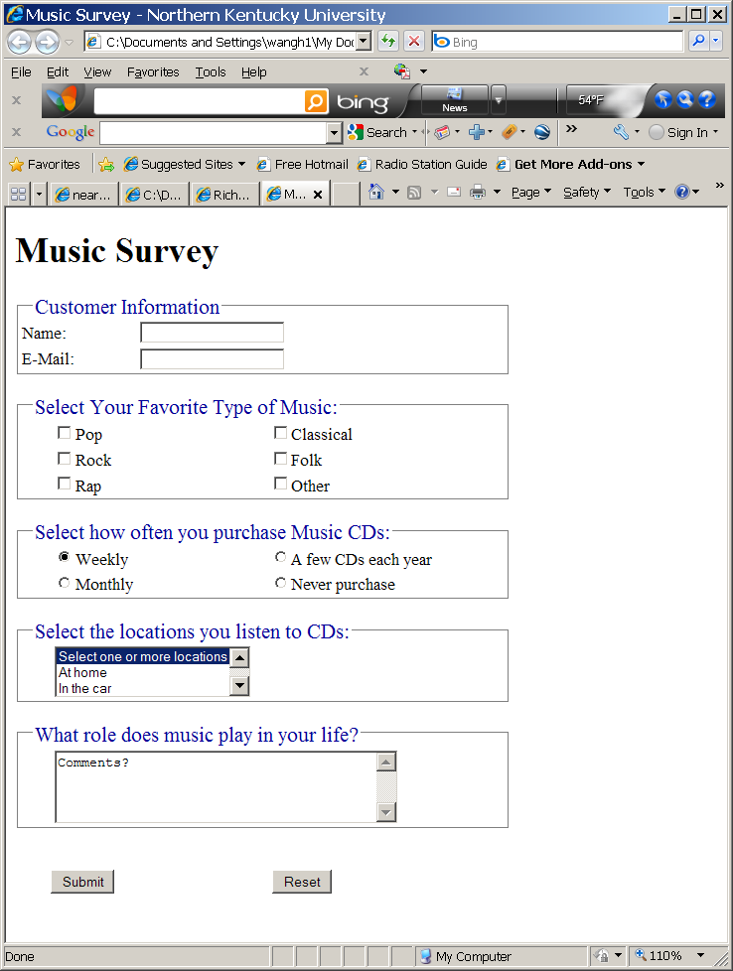
- You should implement the survey using a standard HTML form (10%);
  - Upon submission, the form should invoke a server-side script located at http://webdevfoundations.net/scripts/formdemo.asp;The ASP script will display the information sent upon the submission of your form, as form_elem_name: form_elem_value pairs (see the picture below) .
- Use CSS to style the form (10%);
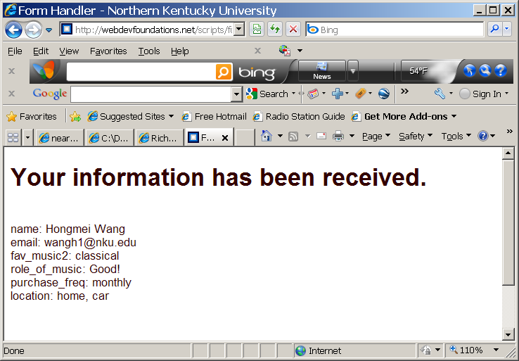
Your survey does not need to look exactly like the one shown above. This is only one possible example. At a minimum, your survey should contain the following form elements:
- Text boxes for name and email address (10%);
- A scrolling text box (40 characters wide and 4 rows high) that allows users to state the role music plays in their lives (12%);
- A check box group with at least three choices (12%);
- A radio button group with at least three choices (12%);
- A select box that initially shows three items but contains at least four items total (12%);
- A visual group with a legend for each group of information (12%);
- A submit button (5%);
- A reset button (5%);

You can choose to include more items (form elements, images, etc.) on your page.
Pleaser save the source code as LastName_FirstName_Assignment8.html and zip it (You MUST zip your code, otherwise it will be automatically modified by Canvas and will not display correctly). Submit the zipped file (i.e. the file extension should be .zip) to Canvas.

